A BRIEF HISTORY OF HUDDERSFIELD BRIDGE CLUB
Millions of people world wide play the game now known as Bridge, in clubs, tournaments, online and with friends at home. In England it is run by the English Bridge Union, or EBU. Duplicate Bridge is a mind sport, comparable to chess in its complexity and mental skills required, and is recognised with chess as such by the International Olympic Committee.
This is the history of Huddersfield Bridge Club from the early beginnings of the game of Bridge.

15th Century: Bridge evolved in from 15th century Italian and French trick taking games such as whist. The dominant game was called La Triomphe or Triomfi – or…. trump.

19th Century: Russian Whist, (Biritch) was invented, and the concept of the Dummy. “Biritch” means “clerk”, but it’s possible that British soldiers invented the game during the Crimean War, as they crossed the Galata Bridge on the way to a coffeehouse to play cards.

1886: The First Rule Book for Bridge, by John Collinson in Istanbul, let the dealer choose the trump suit, or nominate his partner to do so. Biritch! was called If the declarer chose NT. Scores could be doubled, or redoubled, and game could be made in NT (3 tricks), hearts (4 tricks) or diamonds (5 tricks). There were no games in clubs or spades, but bonuses were given for bid or unbid slams.

1894: The Portman Club in London accepted Bridge as a game in its own right.

1904: Competitive auctions began (Auction Bridge). Penalties were introduced for failing to make The Contract, but there were no bonuses for bid slams.

1925: The main innovations towards modern bridge were made by the American Mr H S Vanderbilt. This included changes to the scoring, and the concept of vulnerability. The game of Contract Bridge had now arrived, now simply known as bridge.
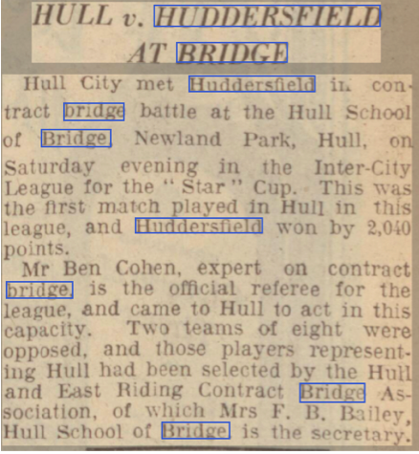
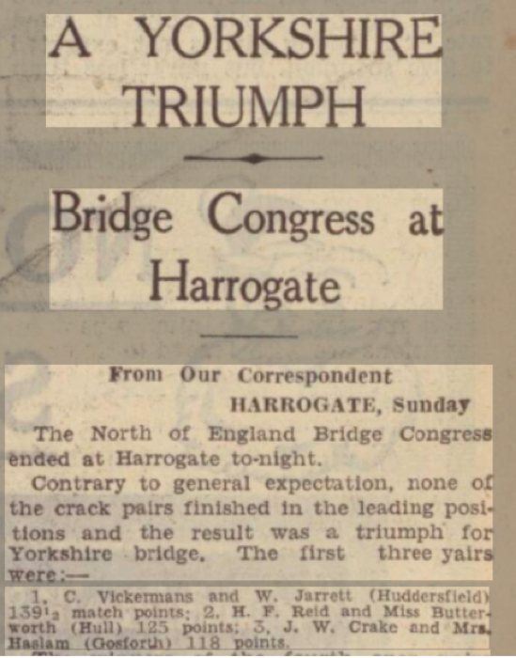
1936: Huddersfield Contract Bridge Association was one of four clubs to form the Yorkshire Contract Bridge Association, along with Sheffield, Leeds, Bradford and Hull. This formed the Yorkshire Contract Bridge Association(YCBA). One of the founder members of Huddersfield was Cedric Vickerman, who was just 31 at the time. He was one of the stars of Yorkshire Bridge, as well as bridge correspondent of the Yorkshire Post and Huddersfield Examiner – he also featured in many copies of the English Bridge Magazine.

1937: HBC played a team game against Hull, in the YCBA league, which they won easily. One of Cedric Vickerman’s first triumphs was at Harrogate in November – see the Newspaper Cutting from the Leeds Mercury.
1938: The following year, a trial pairs contest was arranged by the Midlands Association, to select players to represent the North of England. The Midland contingent were reportedly a “very strong lot” as six of them had taken part in National and International competitions. However, Cedric Vickerman and his partner came out on top, with three Midland pairs occupying the next three leading positions. This was reported in the Yorkshire Evening Post, with an advert for the paper’s Cup Competition – this was reported to be a new competition. All entries had to be sent to C Vickerman, including entry fees of two shillings and sixpence per player. Competitions in the areaa

1948 – 1950: Cedric Vickerman won the Tollemache Cup, and again in 1960. These were amongst the first of many trophies.

1950: Considerable discussion over the team selection for inter city matches.

1951: HCBA had 61 members, a fall from 70 the previous year. However, it was working at a profit of £25, replacing a loss of £20 the previous year. It was agreed that starting times would be strictly observed.

1952: A request to the committee that “permanent headquarters be obtained”.

1953: GD Sharpe and C Vickerman were selected to play in the Wars of the Roses Yorkshire/Lancashire match.
1954: A beginners’ evening was suggested at the committee meetings, and “Inexperienced” events began on alternate Mondays. At the AGM an “inconclusive discussion” arose over the formation of a Bridge Club. Another club in Huddersfield played bridge on a Thursday evening, raising doubts that many people would wish to play bridge twice each week.

1955: Discussion on prompt starts, and the feasibility of completing 28 boards each evening.

1955: The annual rent to Collinsons was increased to four pounds four shillings, causing the HBCA to move to premises in the ballroom at the George Hotel at a saving of one pound one shilling a year. Fines were introduced for mis-scoring.

1956: HCBA decided not to adopt Master Points, and there was a clear direction that “no private systems are to be used, and unusual systems must be explained. The George Hotel increased its rental to five pounds eights shillings, and Collinsons re-offered their room at the knock down price of three pounds a year. At the same time, rooms became available in John William Street, with rent and rates at £285 a year.

1957: Members were asked to provide loans in order to furnish these rooms. Competitions began on Friday evenings, and it was agreed that Master Points would now be used. The committee agreed that the formation of a Bridge Club was not a “paying proposition”. The profit had risen to over £154, which was decreed as being “satisfactory”. Competitions were now held on two Thursdays each month.

1958: GD Sharpe was appointed as first team captain, and competitions began every Thursday and Wednesday. A teapot was purchased for matches!! On October 7th, it was noted that 72 players arrived to play in the regular Monday competition. Concern arose at the AGM over team selection, mis-scoring and mis-boarding. A match was held with Dalton Grange Bridge Club.

1959: Loans of £350 were repaid to members. It was decided that mis-scoring and mis-boarding would be fined.

1960: Championship pairs competitions were held on four Fridays. Complaints were raised over room ventilation.

1961: It was decided that committee meetings would be held on the second Monday of each month. A large majority at the AGM were in favour of buying a house, and an “Intensive, but unsuccessful” search began for new premises. In the meantime, the lease was renewed at John William Street, amid complaints about the heating of rooms. It was agreed that ventilation needed improving. Despite the ruling two years earlier, it was determined that mis-scoring would be fined. It was proposed that Travelling Score Slips should no longer be used, but this motion was not carried. Another call was made for prompt starts in matches.

1962: A house was found in Gledholt Road which was deemed to be suitable as a Bridge Club, but the landlords at John William Street refused to release the HBCA from the terms of their lease. The search for new premises was suspended for two years. Profits had fallen this year. Mr H Castle was elected chairman, with the new post of President given to Mr C Vickerman. Complaints were raised (yet again) about mis-scoring and mis-boarding. There was a lack of support for Championship Pairs, which were not therefore held.

1963: Ventilation was discussed at the committee meeting. A new competition for teams was proposed, to be known as the Huddersfield Cup. The constitution for the Association was not agreed by members, and even amendments to this were defeated. Mrs Singleton was elected to the committee and a stand in system was suggested.

1964: A building fund was established, and a search for new premises resumed. Members were circulated with proposed new rules. The Huddersfield Examiner agreed to willingly provide a trophy (value £15 2S) for the new Teams of Four competition. Complaints about mis-boarding and mis-scoring continue! It was decided that profits could be increased by providing only plain biscuits as refreshments. Prompt starts and late finishes were discussed by the committee. The death of Mr C Vickerman was announced, with Mrs K K Sykes taking over as correspondent to the Huddersfield Examiner.

1964: Number Four Cambridge Road was acquired in October, requiring a bank overdraft of £1400. Members were asked to provide loans towards the costs.

1965: Fines were introduced for mis-boarding and mis-scoring. (!?!?) A stand in was to be provided at meetings. Unpaid subscriptions were discussed, along with complaints about the heating.

1965: Number Four Cambridge Road formally opened on the 27th July. A fruit machine was bought for £475, financed by hire purchase agreement. Within 14 weeks of operation it had takings of £105 10S.

1966: By 1966, the overdraft had been reduced to £1239.

1967: Burnwood Bridge Club began to use the premises on Tuesdays. It was agreed that the windows would be insulated to conserve heat. Mr H Lewthwaite was elected as a member. Smoking was prohibited in the downstairs room – these non smoking places were to belong to the “first pair to occupy seats”. It was agreed that members arriving after 7PM would be turned away.

1968: Unpaid subscriptions were again on the agenda. Complaints were raised regarding the stand ins on Monday, as having “partners in reserve”. It is unclear quite what this meant. A new ventilation system was installed, and Mr H Lewthwaite became responsible for the bar. The overdraft was now slightly over £10. Mr B L Ellam was elected as chairman, following the retirement of Mr H Castle. Mr Lewthwaite was elected to the committee. The smoking ban was rescinded, with 19 – 17 votes in favour.

1969: R Q Hotyle became tournament director on Fridays. Ongoing complaints about late starts and finishes, especially on Mondays. Mr N Wimpenny was elected as a club member.

1970: The membership was expanding, although no figures are available. There was a clear need to extend the premises or find new ones. The Club Championship Pairs was revived.

1971: Again continuing complaints re mis-boarding and mis-scoring, along with slow play.

1971: Number Six Cambridge Road was acquired on the first of July, raising the overdraft to £2659.

1972: Ten teams entered the Local League. It was declared that the stand in rota was not working, and again stipulated the late comers were not to be accepted. A trip to Iceland for members was discussed.

1973: Mr B L Ellam retired as chairman, being succeeded by W H Gibson. Mr Ellam and Mr Castle were made vice presidents.

1974: Members were again asked to provide interest free loans, and these were raised to the tune of £1035. It was agreed that players must be seated by 6.45. The trip to Iceland was agreed. A cut glass decanter was given to G K Dobson for 21 years’ service as treasurer. Fines were agreed (again) for mis-boarding and mis-scoring.

1975: Members must be present at 7PM or more drastic action would be taken. Tuesday night bridge began, and there was a return trip to Iceland.

1976: Loans were partially repaid. It was decided that to place thermostats on radiators was too expensive, despite the club being too hot. Mr H Castle was appointed Chairman of the Yorkshire Contract Bridge Association. Wednesday attendances were decreasing.

1977: The committee was expanded to 7 members. Despite some unpaid subscriptions there was a credit balance of £893. The Swedish National Team played two Yorkshire teams at the club premises.

1978: It was agreed that young players were to be encouraged to become members. A team including GDS (?) and R Garthwaite reached the Crockfords Cup Final.

1979: W H Gibson and M Foulds reached the finals of the Gold Cub, and Gillian Boothroyd, C Bottomley, B Senior and Ruth Pierce won the Huber Philip’s Bowl. Continuing low attendance on Wednesdays.

1980: W H Gibson resigned as chairman, and was made vice president.

1981: The death of Mrs N Coates was announced. Methods of attracting younger players were again discussed. No smoking tables were also discussed, but not implemented. Good attendances were reported every day but Wednesday, which showed the lowest attendance for the past 23 years. The stand in system was seen to not be working. Honorary membership was conferred on Mr G K Dobson. The club was now £1600 in credit.

1982: The death of G K Dobson was announced. There was ith a further rise in credit for the club to £3000. W H Gibson and M Foulds were members of the team that won the Silver Plate.

1983: A repetition of complaints regarding unpaid subscriptions, central heating and Wednesday evening attendance. Despite a small deficit for the year the club has a £2500 credit.

1984: A falling membership was declared, with only three teams entered for local league. However, new members were being admitted, as a result of the last year’s bridge lessons, and the club’s credit had therefore increased to £3500. Mrs Singleton, Mr Castle and Mr Lewthwaite were made honorary members.

1985: The no smoking room was re-implemented for a trial period.

1997: The first Computer Bridge Championship was held in Albuquerque in 1997.

2001: The World Bridge Federation made a set of laws for online play.

2017: The Laws of Bridge were updated, and are scheduled to be updated every ten years.

